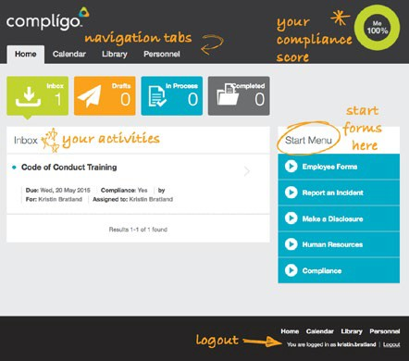

**A**

**Now you are Home…**

Your **HOME PAGE** is where you complete your assigned **Inbox Activities** such as policies, forms and trainings, **start forms**, view your **compliance score** and **navigate** to your Calendar, Library and Personnel file.

**Forms,** that can be started any time, are quickly located by typing the name of the formand selecting it from the drop down list.

**Navigation** is easy across tabs simply by clicking where you want to go:

* The **Calendar** allows you to track and request time off
* The **Library** houses all your company con-tent, including the Employee Handbook
* Your **Personnel** file stores all your completed activities; policies, forms, trainings, etc.

Welcome to... user’s guide.



1. Type in your **Username** and default **Password**. Your default password is:

**[your default password]**

1. Click the **Login** button

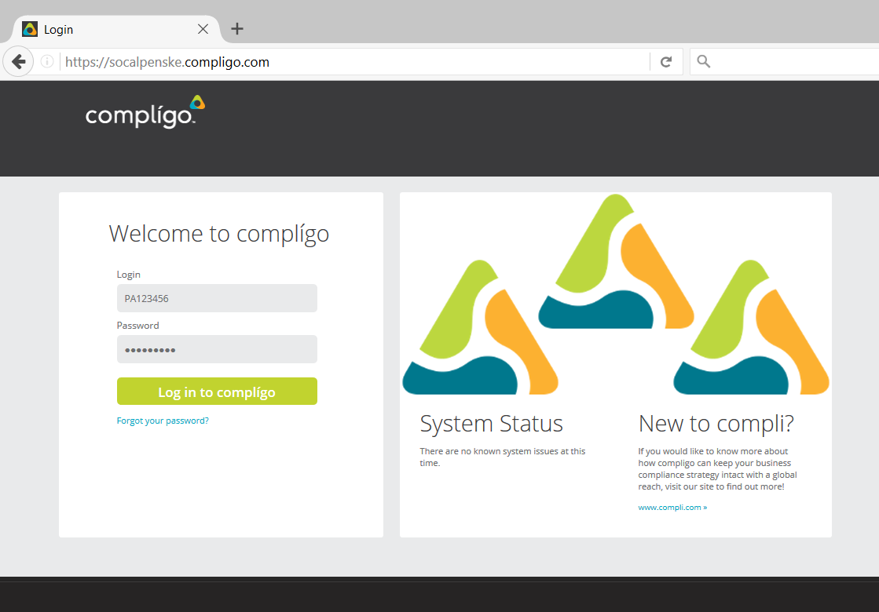

**Let’s get you Logged-In…**

1. Use your specific company Complígo site **URL** to get to your login page.

**https://yourcompany.compligo.com**

1. The first time you will need to **reset** your **Password** and select a **Security Question** and **Answer**.

Welcome to your **Quick Guide**

for **Complígo** as an end user.

The following information will help you use the new platform quickly. We know Complígo will be your most **efficient** and

**easy to use** automated management system for your compliance obligations.

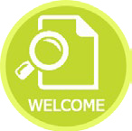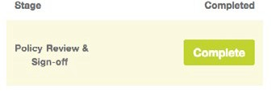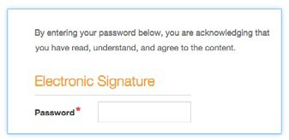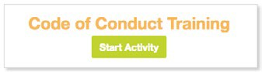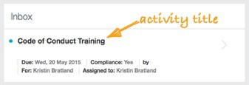

**Complete a required Activity…**  
To complete a required activity, from your inbox follow these steps:

1. **Select** the activity from your inbox by clicking on its title.

2. Click the **Start Activity** button

1. **Review** the activity, complete any requested information
2. **Sign** by typing your password

5. Click **Complete**

**Yes**… it is that easy!